1. Agenda:
   1. How to create Docker images for our microservices account, loan, Card.
   2. How to run them.
2. 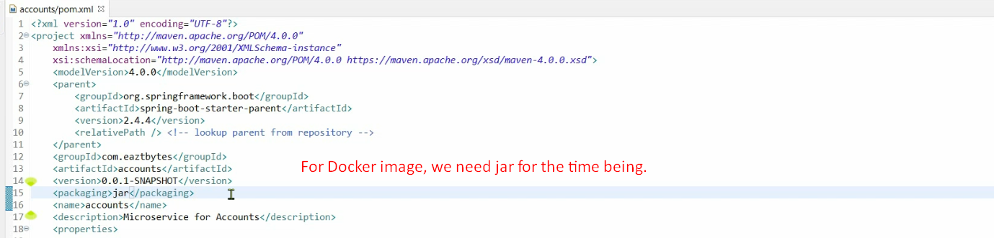
3. 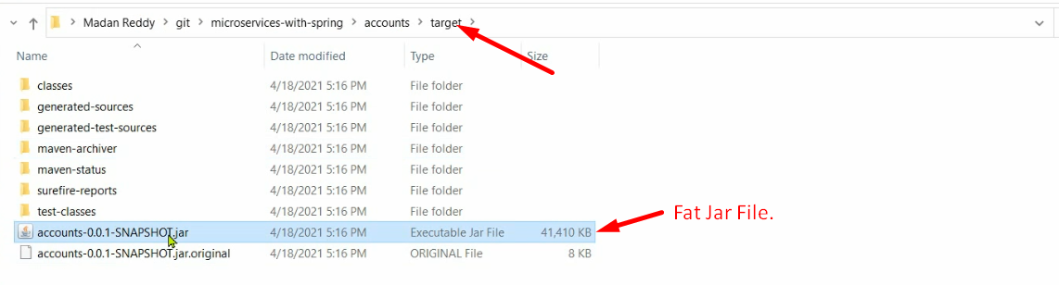
4. 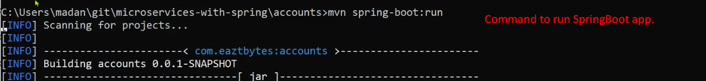
5. 
6. Let’s see the process of creating Docker Image.
7. Many ways to create a Docker image.
8. Let’s see the first lengthy way of creating Docker Image.
9. 